[https://www.udemy.com/course/complete-python-developer-zero-to-mastery/learn/lecture/16543436#questions](https://www.udemy.com/course/complete-python-developer-zero-to-mastery/learn/lecture/16543436" \l "questions)

1. Go to the folder you want:

cd “D:\CIRO (Estudos Compactados)\CENTENNIAL\CENTENNIAL (ENERGY ENGINEERING)\Matérias\Python\Git Hub\Contributing to the community”



1. Go to Git Hub and Fork the Open Source or the Community:

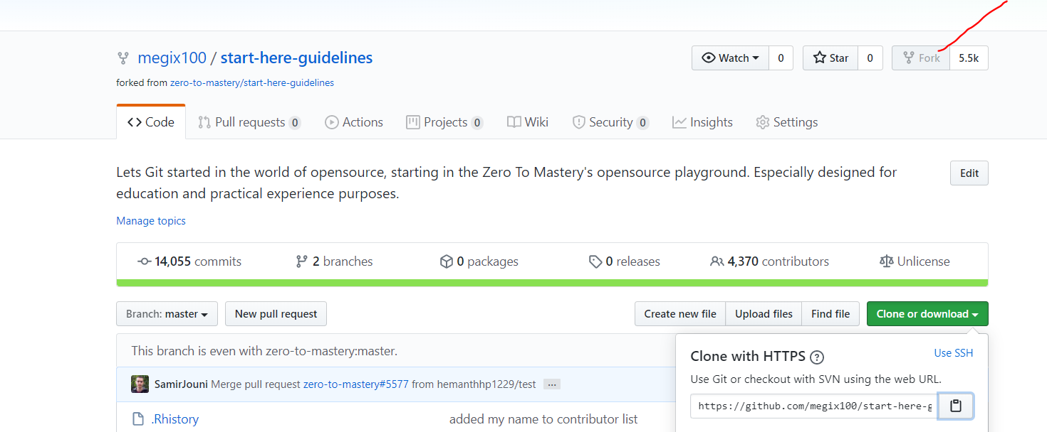

1. Go to Clone and copy the link:

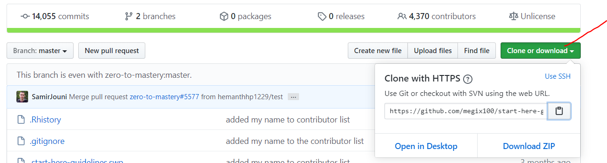

1. Go to the Windows Power Shell and Type:

git clone LINK



1. Check the name of the file and go inside the one you cloned in your offline folder:

cd” D:\CIRO (Estudos Compactados)\CENTENNIAL\CENTENNIAL (ENERGY ENGINEERING)\Matérias\Python\Git Hub\Contributing to the community\start-here-guidelines”



1. Open the folder in sublime text:

sublime.

OR:

Just open the file in Sublime

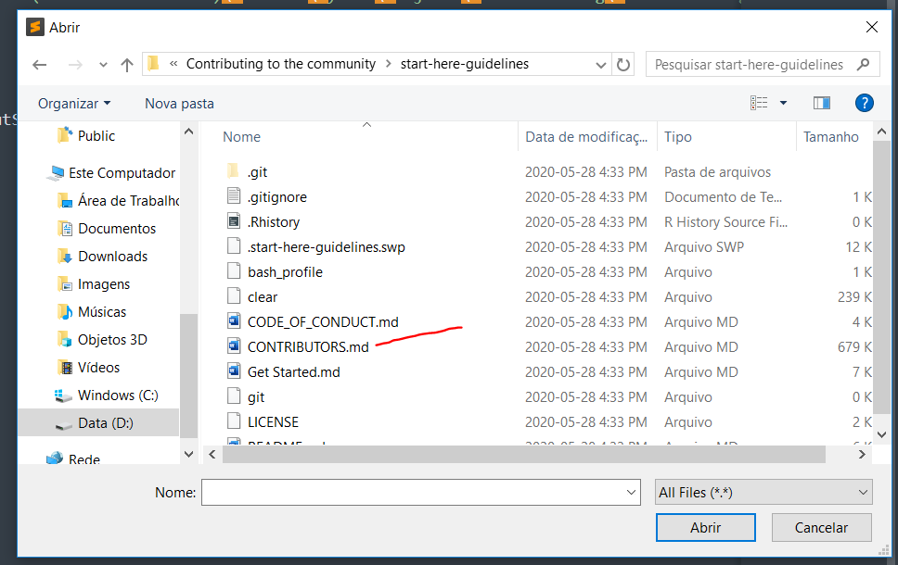

1. Create another branch in Windows Power Shell:

git checkout -b NAME OF THE BRANCH



1. Update the file Contributors

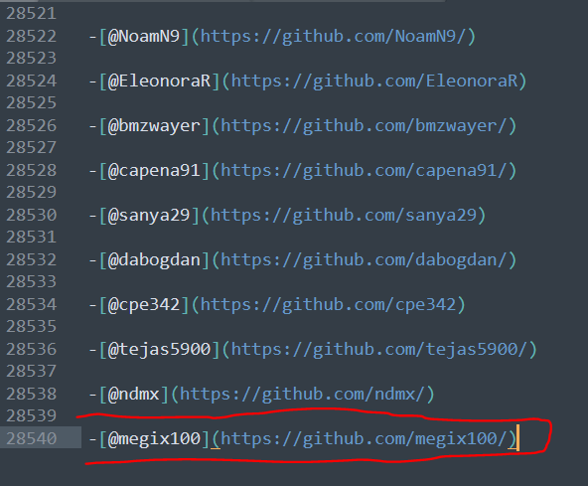

1. Save the file in sublime text
2. Type in Windows Power Shell :

git status

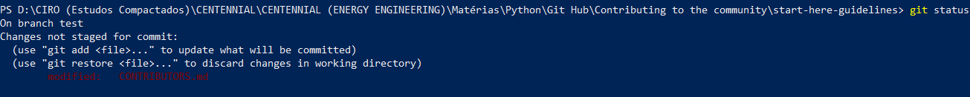

1. Type in Windows Power Shell:

You will need to use your USERNAME and E-MAIL from Git Hub

git config user.name “USERNAME”

git config user.email “E-MAIL”



1. Type in Windows Power Shell:

git add NAME OF THE FILE



1. Type in Windows Power Shell :

git commit -m “ADD A TEXT”



1. Since we forked the project before we will push from origin (your Git folder) to the master or to the branch, so the admins can update

Type in Windows Power Shell:

For the Branch: git push origin NAME OF THE BRANCH

For the Master: git push origin master

1. Go to git hub:

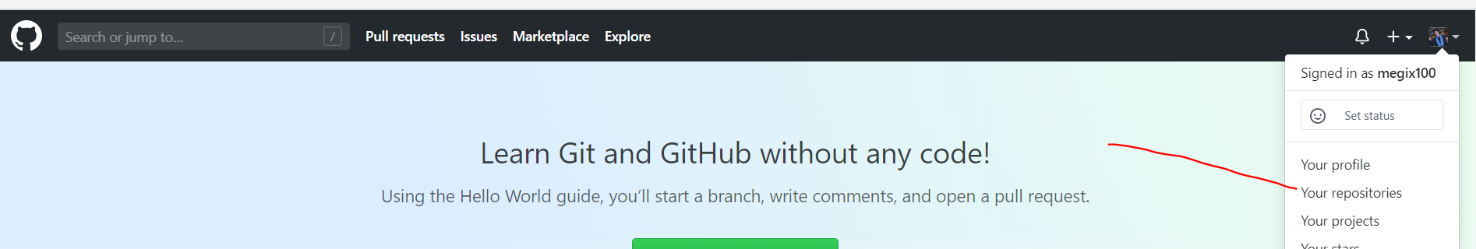

1. Click in the new repository you have in your folder and the Branch you put your files, click in Pull Request:

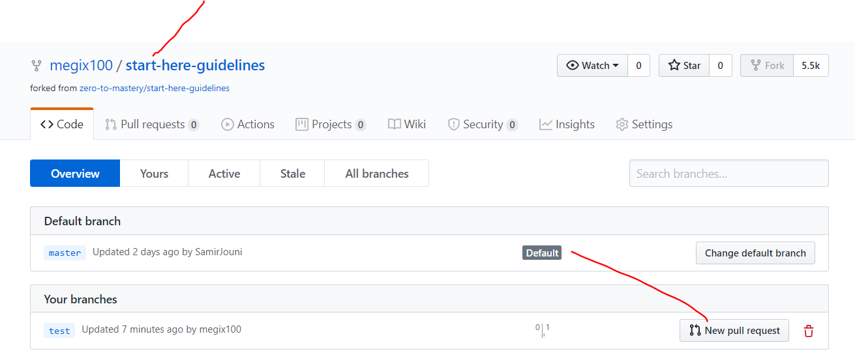

1. Add a comment and Call one of the administrators

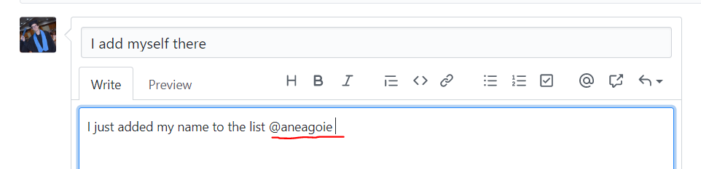

1. Create a pull request

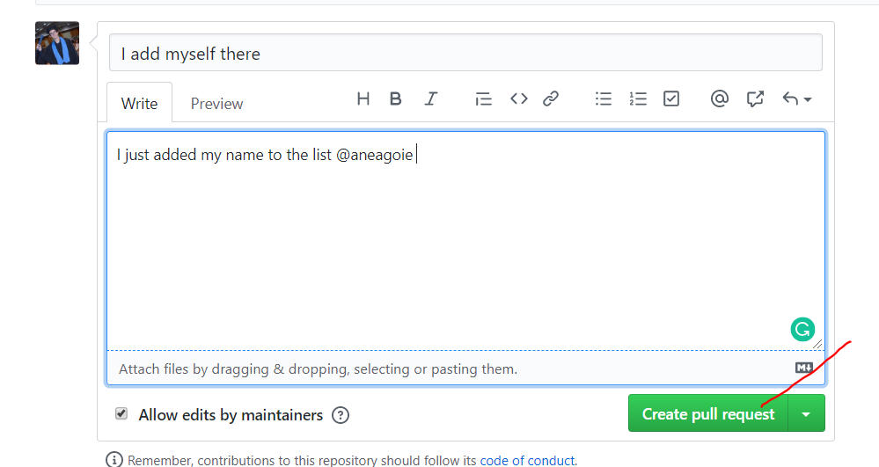

1. s